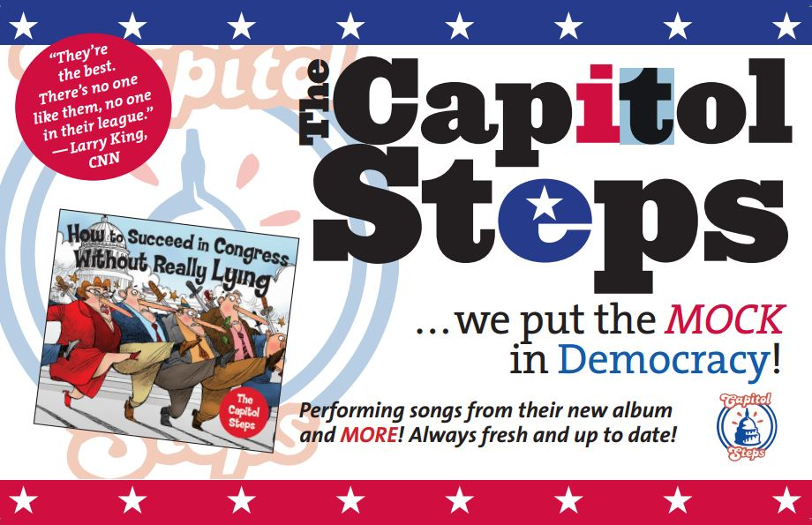
Straight from D.C., THE CAPITOL STEPS bring their brand of bipartisan comedy, songs & skits to Damascus!

If you ever wanted to hear Pres. Obama sing show tunes or Gov. Christie dance ballet, this is the show for you!

SUNDAY, MARCH 15, 2015 7 pm
Damascus High School aUDITORIUM

http://bit.ly/1BEYzJw

Tickets $30 in advance or $40 at the door (if available)
All proceeds benefit the Damascus & Clarksburg PTSA Post Proms
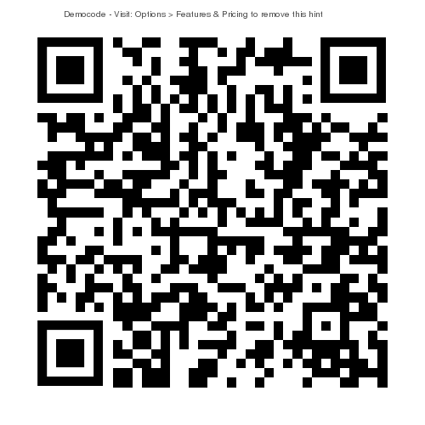
FOR MORE INFORMATION visit
http://dhsptsa.weebly.com/

